12ENC ASSESSMENT TASK 3a
ENTERPRISE PROJECT

Your Name: | Eamon Wong

TABLE OF CONTENTS

TABLE OF CONTENTS 2
SECTION 1a: IDENTIFYING AND DEFINING 3
SECTION 2a: RESEARCH AND PLANNING 5
SECTION 3.1a: PRODUCING AND IMPLEMENTING THEORY 8

SECTION 1a: IDENTIFYING AND DEFINING

Milestone: This section should be completed by Term 1, Week 1.

Guide: 1 A4 page

1.1 Problem Definition – Describe the problem that needs to be solved and the purpose and requirements of the new system in relation to the task.

A problem definition is a concise summary that outlines the requirements for a project. This statement may provide context for a new system in areas such as:

Purpose

Design elements

User needs

Time frame

Budget

Required technology

Enterprise requirements
Purpose:
Fishing charter companies lose lots of money and customers through negative reviews from customers that could not catch any fish, my platform aims to provide charter companies with a comprehensive tool that allows for in-depth and analysed geographical data from historical catches to provide species-targeted experiences for future customers. This will not only save companies customers’ but also fuel and time by showing them the exact spot to go to maximise fish catches and reduce time spent driving around.

Design elements:
The platform will provide an interactive map GUI with specific overlay and visual settings for different categories and filters, featuring a high-contrast option to combat sun-glare, and large text and buttons to reduce unintended miss clicks.

User Needs:
Fish charter companies need a system that allows for filtering results and overlays to account for changes in weather, location, time and other factors, which will be present in the platform, allowing companies to filter by certain months, years, seasons, distance from shore, and that features instantaneous coordinate generation to minimise time loss from using the system.

Time Frame:
Completed by Term 3, Week 1. With a working prototype by Term 2 Week 4.

Budget:
The system does not require a budget of monetary value, however much time is required for the development of this software which must be used efficiently to remain on time for release.

Required technology:
The system will require the presence of the following software components. A coding environment (such as Visual Studio Code), Python3 installed and configured correctly, including the Streamlit framework and Folium mapping library. Microsoft Excel is also necessary for data retrieval. The system does require a physical hardware device to display, such as a laptop or a Garmin tablet that can be mounted on boat dashboards.

Enterprise requirements:
There are also a few requirements for the system to be a viable option and resource for fishing charter companies which is that the system must be able to quickly process the vast amounts of catch data and produce a easily decipherable visual for users to minimise time spent searching for fish, saving money (through fuel consumption). Additionally, the system must also be able to receive both software updates and fish catch data updates to continue to keep the system current with recent trends. Similarly, the system must be able to function without internet connection as most charter boats go many nautical miles offshore where there is not mobile data reception, however if there is internet connection present (through a system such as Starlink), the system must be able to utilise this connection to enhance and provide users with up-to-date and current information to maximise chart company’s profits and provide customers with a valuable experience.

SECTION 2a: RESEARCH AND PLANNING

Milestone: Section 2 should be completed by the end of Term 1 Week 3

Guide 2.2: 3 A4 pages

2.1 Planning - Construct a logbook that documents your work throughout the task.

Your logbook should be stored in your AT3a folder within your 12ENC folder on OneDrive. Place a link to your logbook here:
12ENC AT3 Logbook 2026.docx

2.2 Research - Describe key collaborating and managing criteria appropriate to the development of an enterprise project and justify your choices, including:

designing for ease of operation and maintenance

clarifying each of the relevant informatics within the new system

outlining the role of the participants, data and components used in the system

include an assessment on the data you have acquired

Quantitative/Qualitative; Data Types; Levels of Measurement; Structured/Unstructured

negotiating user/client needs and wants
In order to successfully develop and implement a fish catch heatmap enterprise system, in-depth research and planning must be carried out in order to meet all the enterprise systems’ requirements. By defining the key requirements for design to combat the constantly changing environment of the marine space, and map historical fish catch data, providing insightful and complete representations of patterns identified from the data, the enterprise system can successfully complete the requirements, creating a system that operates offline, but still provides a large range of unaffected features for fishing charter companies to utilise and thus save time, effort and money by providing accurate and representative infographics for use.

Ease of Operation:
Within the development of this enterprise system, the focus on Ease of Operation is a critical aspect of the development. This is due to the constantly changing nature of the environment that of which the system will need to operate within. The system produced must be able to be operated by a single individual whilst also operating and controlling a moving sea-vessel, thus the system must feature an easy to use interface (Such as a Graphical User Interface [GUI]) that provides protection against unintended actions by the operator. The platform will feature a high contrast visual theme as well as settings to provide compensation for sun-glare and sea spray common off-shore. Additionally, the system will provide large, distinct user buttons, spaced decently apart with a minimum press-timer in order to activate its function, this is in order to again reduce the likelihood of unintended actions due to physical conditions such as sea swell and saltwater covering the screen of the device. Similarly, the system will also feature instant and easy to understand filtering options, allowing for instant coordinate selections, measurements and generation, minimising processing times and allowing the operator of the vessel to focus on navigation rather than trying to interpret a complicated system.

Ease of Maintenance:
In order for the system to maintain its relevance within the fishing “sphere”, the enterprise system will also feature an easy to synchronise feature that pulls new fish catch data from a GitHub repository directly into the system. The synchronise feature will run every Monday (NSW, +10, EST), on which it will check for new data every 5-10 minutes whilst the device is connected to the internet. This is because new data is only uploaded to the public by the Department of Fisheries every Monday. This allows the system to maintain its long-time relevance within the Fishing Charter Software market and provide accurate and up-to-date predictions, whilst still providing updates and security patches after the initial release.

Clarifying Informatics (IPO):
Inputs:
The main inputs within the enterprise system is the historical fish catch dataset, which contains historical records of fish caught retrieved from the NSW Department of Fisheries. Additionally, the enterprise system also features user-selected filters such as the specific species and years.

Processes:
The processes of this enterprise system include the Python backend which utilises the open-source, Pandas library which supports “dynamic filtering” datasets based off inputs suggested by the system or from the users.

Outputs:
In the enterprise system, the outputs produced by the system include the filtered geospatial data visualised as interactive heatmaps for users to easily interpret.

Role of Participants, Data and Components:
Participants:
The enterprise system is specifically targeted at Fishing Charter Companies as the end users and customers who will be using the enterprise system for monetary means. The secondary participants include the recreational fishermen who are submitting fish catches to the NSW Department of Fisheries.

Data:
The data for the enterprise system is the historical fish catch data that is retrieved from the NSW Department of Fisheries. Without this data, the enterprise system cannot function in its intended purpose to deliver suggestions and predictions based of historical data.

Components:
The components of the enterprise system include a mix of hardware and software parts. The software components include the Python 3 language, the Streamlit framework and library, the Folium library and Microsoft Excel which is used for the initial formatting of data. The hardware components include the physical device that the enterprise system will be running on, only requiring that the device can run the latest versions of browsers such as Chrome, Bing or Safari.

Assessment of Acquired data:
The primary dataset that is used by the enterprise system is of high structural format, containing 9 columns of data for each row containing limited variables. However, the highly structured dataset allows for the data to be easily process and filtered by Python 3, allowing for easy visualisation and processing of both quantitative and qualitative data types:

Quantitative Data:
This data includes the exact geological locations of the records in latitude and longitudinal coordinates. Additionally, the dataset also features columns for length (integer) and weight (a float). Additionally, the coordinate columns have been rounded to 2km squares in order to reduce the load on the Folium API to produce heatmaps but also accounts for the drift that sea vessels most likely experienced between the time of catching the fish and logging the catch.

Qualitative Data:
This data includes the categorical variables within the dataset, such as the fish species names (strings). This allows for the filtering of generated datasets to be filtered by species names by restricting the data set to only include relevant fish species for the target customers.

Negotiating user/client Needs and Wants:
In order for the produced enterprise system to be successful in its intended purpose as the best available platform for fish predictions, the system must prioritise the needs and wants of the targeted customers. Identified through the customer surveys, one of the biggest points is the ability to function completely without internet connection. Additionally, if internet connection is an available option for the fishing charter, the enterprise system must also be able to download and retrieve live information from API’s such as weather data for locations (to show weather maps) and to download new fish catch records from the NSW Department of Fisheries, however this functionality is secondary to the importance of offline functionality.

SECTION 3.1a: PRODUCING AND IMPLEMENTING THEORY

Milestone: Section should be completed by Term 1 Week 7.

Guide 3.1.1: 2 A4 pages;
Guide 3.1.2: 2 A4 pages;
Guide 3.1.3: 1/2 A4 pages;
Guide 3.1.4: 1 A4 page;

3.1.1 Producing - Conduct interviews and surveys in relation to the creation of the new enterprise system. Analyse the results.

The collected data is organised into suitable form (Spreadsheets/DBs) for analysis to prioritise problems. A requirements report is created to summarise the data. All relevant files should be stored in your AT3a folder within your 12ENC folder on OneDrive. Links to these files should be incorporated into your response below as appropriate.
Surveys:
Questions:
- Operational Question: What type of fishing charter do you operate and what are your primary targeted species?
- Current Issues: What is the most significant challenge or cost-drain your business faces when trying to locate fish for clients?
- UI/UX Wants: Describe the physical conditions which you use screens mostly on your vessel. What specific interface design features would be desirable for these conditions?
- Target Idea: If you had access to an interactive map that could help predict fishing areas, what specific filters (e.g., time of year, weather conditions, species) would be the most critical/useful for your daily planning/fishing?
- Hardware and Connectivity: What devices are currently being used on your vessel’s dashboard? And how reliable/available is an internet connection during one of your typical charter sessions?
- Offline Functionality: On a scale of 1 to 5 (1 being unnecessary, 5 being critical), how critical is it that the software functions at 100% capabilities whilst offline without mobile data?
- Predictive Features: Which of the following predictive filters would best save your business the most money in fuel and time?
A) Historical Catch Density for a specific specie/species
B) Live Sea Surface Temperature (LSST)
C) Tide and Rainfall changes

AI Responses:
Persona 1: Captain "Deep Sea" Dave (The Offshore Big Game Hunter)
- 1. Operational Question: "We run heavy-tackle deep-sea charters, going anywhere from 20 to 50 nautical miles offshore. Our primary targeted species are pelagic fish like Black Marlin, Yellowfin Tuna, and Mahi Mahi."
- 2. Current Issues: "Fuel consumption is by far our biggest cost-drain. If we guess the fish's location wrong and spend hours trolling empty ocean, we burn hundreds of dollars in diesel and end up with frustrated clients."
- 3. UI/UX Wants: "We operate in heavy sea swells and blinding mid-day sun. Because the boat is constantly pitching up and down, precision tapping is impossible. Desirable features would be a stark, high-contrast screen (like bright colours on a black background) and massive, spaced-out buttons."
- 4. Target Idea: "If I had that map, the most critical filters would be sorting by specific species and the exact month of the year. Being able to overlay sea surface temperature (SST) and wind direction would also be highly useful."
- 5. Hardware and Connectivity: "We currently use a mounted Garmin tablet on the dash. Once we get past 15 nautical miles, our internet connection drops to absolute zero. Any system we rely on must be fully functional offline."
- 6. Offline Functionality: "5 - Absolutely critical."
- 7. Predictive Features: "A - Historical Catch Density. Knowing exactly where the Marlin were caught this time last year saves me hours of blind trolling."

Persona 2: Captain "Estuary" Emma (The Inshore/Family Charter)
- 1. Operational Question: "I operate half-day family and beginner charters inside the harbour and just outside the river mouths. Our primary targets are Flathead, Snapper, and Bream."
- 2. Current Issues: "Our biggest challenge is dealing with constantly changing tides and rain runoff, which forces the fish to move. If I can't locate them quickly, the kids get bored, the parents get annoyed, and we lose repeat business."
- 3. UI/UX Wants: "Our waters are usually very calm, so boat movement isn't the issue. However, the sun glare bouncing off flat water is intense. A clean, bright 'light-mode' interface with simple checkboxes and highly legible text would be best for my conditions."
- 4. Target Idea: "Filtering by recent rainfall amounts and tide levels is vital for me. I would also find it incredibly useful to filter by historical catches from the exact same season or month in previous years to establish patterns."
- 5. Hardware and Connectivity: "I use an iPad Pro secured to a dash mount. Because we stay close to the coast and inside the harbour, I have full 5G mobile data 99% of the time, so my internet connection is extremely reliable."
- 6. Offline Functionality: "2 - Not very critical. I have 5G in the harbour."
- 7. Predictive Features: "C - Tide and Rainfall. Estuary fish move completely based on the tide."

Persona 3: Captain "Tech" Tom (The Modern Reef/Sportfishing Charter)
- 1. Operational Question: "We do high-speed sportfishing and deep reef jigging. We primarily target Kingfish, Coral Trout, and occasionally Sharks. We do a lot of pre-dawn departures."
- 2. Current Issues: "Information overload and time-wasting. I currently have to check three different apps for weather and tides and cross-reference them with my paper catch logs before we leave the dock. It eats up valuable fishing time."
- 3. UI/UX Wants: "Because we leave in the pitch dark, my screens need a proper 'Dark Mode’, so I don't ruin my night vision. Additionally, because we travel at speeds over 30 knots, the interface must be clutter-free and readable at a split-second glance."
- 4. Target Idea: "I would need filters for distance from shore and specific months. The absolute most critical feature for me would be the ability to click a hotspot on the map and instantly copy the exact GPS coordinates to drop straight into my boat's navigation."
- 5. Hardware and Connectivity: "I run a rugged marine laptop at the helm. I recently installed a Starlink dish on the roof, so I actually have high-speed satellite internet available and highly reliable during the entire charter session."
- 6. Offline Functionality: "4 - Very critical. I have Starlink, but if it drops out, I can't be flying blind."
- 7. Predictive Features: "A - Historical Catch Density. I want to go straight to the reef where the Kingfish are biting."

Analysed Results:

Survey Question Types:
In order to collect data for a variety of metrics, the survey utilises both qualitative and quantitative data questions. The survey questions 1-5 are open-ended questions in order to gather a wide and insightful set of data from the survey’ers. This allows for specific data to be collected about different customer types (such as deep-sea charters versus inshore family charters). Similarly, questions 6-7 are quantitative data questions that allow for the collection of measurable data that can be used to create priority lists for features that are identified through the survey. Overall, the mix of qualitative and quantitative data questions on the survey allow for a wide selection of feedback that will directly influence the enterprise system’s design and functionality.

Response Analysis and functional/non-functional requirements defining:

Functional Requirements:
By analysing and interpreting the results of the user survey, the following functional requirements were identified as of a high priority to produce an enterprise system that best fulfills the customers’ wants and needs:
- Data Filtering and Processing:
  - The system must be able to quickly retrieve, process and accurately analyse large sets of historical fish catch data. The system must also feature a filtering algorithm that allows the customers to specify parameters such as target species, months, and years for example. These parameters were identified as the highest importance from the survey for conserving as much fuel as possible for route planning.
- Map Generation:
  - The system must also be able to generate interactive geographical maps and map overlays (the heatmaps) that allow for accurate route plotting whilst displaying historical fish catch data directly correlating with latitude and longitude points on the map.
- Coordinate Locating:
  - The survey conducted revealed that providing a system to instantly copy coordinates on an interactive map. Users should be able to interact with the generated map and heatmap overlays to locate a specific coordinate (A GPS system with latitude and longitude) which then can be copied to their clipboard. The format of copied coordinates must also be able to be directly pasted into existing navigation hardware to reduce the “information overload” issue that the “persona 3” mentioned by making the system easy to understand.
- Offline Functioning:
  - The survey results also identified that a system that has offline functionality capabilities would be instrumental in creating a successful enterprise system. The system must be able to perform all of its basic/core data filtering, calculations, heatmap generations and coordinate generations entirely offline on the users’ device. This will ensure a 100% functionality uptime even if there is not mobile data or Star-link connection.

Non-functional requirements:
By analysing the data collected through the survey’s results, the following non-functional system requirements were identified as of being useful in certain situations but not essential to the functioning of the enterprise system:
- UI/UX usability:
  - The system must have a graphical user interface (GUI) that is highly customisable and adapts to the highly changing physical environment that the customers will be operating the software in. The system must feature toggle-able visual features, which will include high-contrast dark and light-mode for night and day use as well as reducing the effects of sea glare. Additionally, the interactive parts of the system (such as buttons and sliders) will be oversized in order to reduce the chance of unintentional actions due to the physically “unpredictable” environment that offshore environments cause.

- Universal Hardware usability:
  - The survey has identified that the need for the enterprise system to be universally usable on a range of different software architectures that are present on vessels. Most fishing charter companies use many different hardware and software components from different companies in a complex and “fragmented” system within the boats. However, by utilising a web-based platform to run the enterprise system on, the system will be able to run with complete functionality across many different systems, such as Garmin, Android, Apple, Windows, or other operating systems.
- Performance and user latency:
  - The requirement for a low-processing-latency requirement was identified through the survey responses. Thus, the system will need to be able to process and render new and updated datasets, able to switch between filter parameters easily in order to preserve valuable time that highspeed fishing vessels can’t waste by waiting for slow rendering of heatmaps while simultaneously operating their vessel at high speeds (identified from persona 3).
- Data reliability:
  - The system must also make sure that there is minimal to zero data corruption or loss while processing or filtering data, as well as preventing application crashes when the system switches from offline to online mode (and new data sets are collected and uploaded into the system). Thus, the system must be able to easily switch between offline and online modes, as well as ensuring that transferred data is not lost, by communicated without loss.

Final Analysis:
Overall, the use of a mixed data-question survey to collect data from a range of different charter “personas” allowed for greater in-depth analysis and identification of the functional and non-functional requirements for the enterprise system. The analysis has revealed that it is more important for the system to be able to provide offline access to the data than to be able to predict current patterns for offshore fishing charters. Therefore, the developed enterprise system will be developed using python3 and CSV files to provide robust and a dependable system that is unlikely to cause errors or issues while used in a wide range of physically challenging environments.

3.1.2 Producing - Produce an analytical report in relation to the new enterprise system.
This analytical report models and generates the data flows and structure of the enterprise system: The Fish Heatmap System. Through analysing the feedback collected from the user surveys, and identifying key requirements, the system will be focussed on providing a structurally robust enterprise system that provides continuous offline use, functions with minimal input delay, and supports multiple different platforms. The system will run locally on customer devices, with content only needing to be downloaded once for use. Instead of utilising a live, online database service to store the backend data, the system will instead use Python and CSV formatted databases (flat file) that store the historical fish catch data. The system will also run on Python, allowing for the simple integration of code libraries such as Pandas, allowing for direct interactions with the CSV flat-file databases stored locally. The customer will interact with a dynamic HTML and JavaScript front-end, generated using the StreamLit farmwork. This will allow for interactive usage as well as allowing universal access for any standard device with a web-browser. Another library that will be used is the Folium library, which handles the geospatial coordinate mapping, allow for the creation of interactive visual heatmaps from the raw CSV flat-file database coordinates.

Technical Feasibility:
The current system relies on fishing charter captains manually entering their own fish catch data into the application, creating their own individual dataset of which predictions and suggestions are made. Similarly, the existing system is able to operate on a wide range of hardware devices (such as iPads, laptops and even mobile devices), however, with the system not requiring internet connection, the GPS coordinates of fish catches must be copied and entered manually from a different source (e.g. the boats GPS navigation system). In order to improve on the issues of the existing system, the new enterprise system will be able to function completely offline but also feature a connection with a wide range of maritime vessel hardware (such as connecting directly to a boats GPS receiver) to allow for greater accessibility and usability for fishing charter captains. Additionally, whilst the new system will still utilise local CSV files to store historical fish catch data, whenever there is internet connection available on the hardware device, the system will automatically check for any new entries or uploads to update the data set, thus keeping the system predictions and suggestions relevant and correct.

Context Diagram:
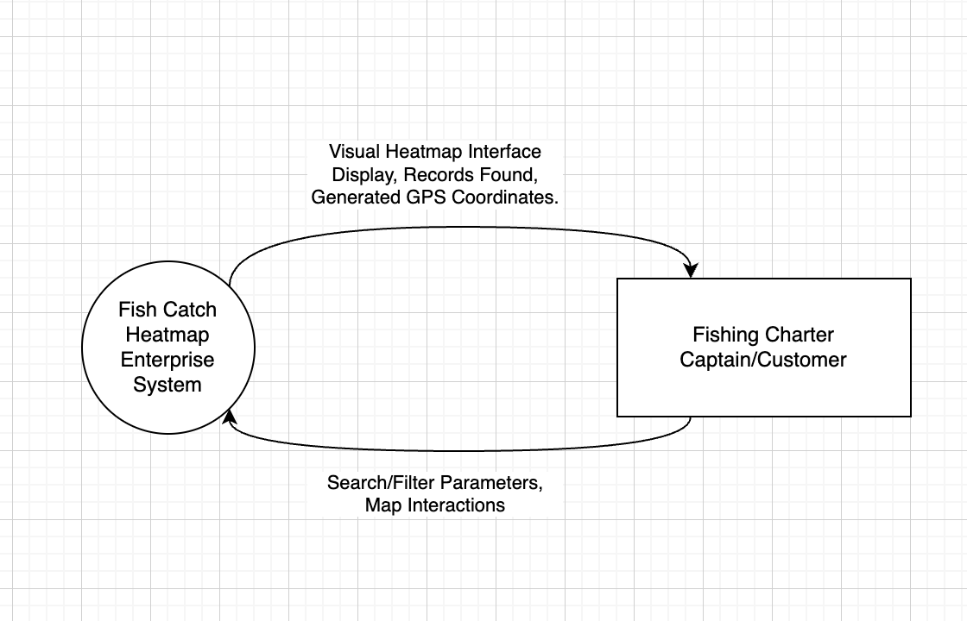
Explanation:
The customer/fishing charter captain inputs their search filters and criteria to the system (this can include options like species name, year, month etc.). The customer/fishing charter captain can also input a map interaction (clicking on a location on the interactive map) which sends the mouse location to the system.
The system receives the inputted search filters and criteria and returns a generated visual heatmap interface back to the customer/fishing charter captain. The system also processes the location of the mouse interaction, and generates the exact coordinates of that location, which are then returned to the customer/fishing charter captain through copying them to their clipboard.

Level 1 Data Flow Diagram:
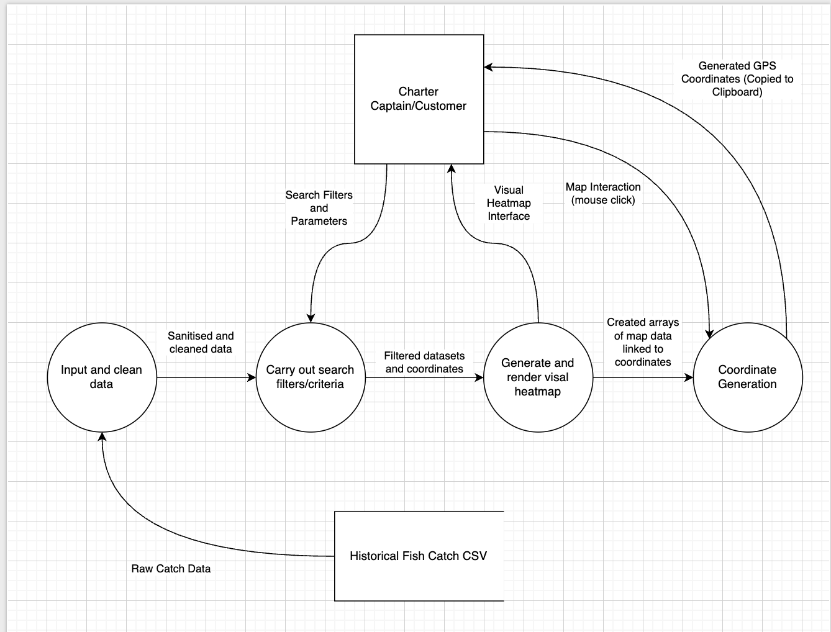
Explanation:
The system retrieves the raw catch data from the CSV flat file datastore and cleans the data by filtering out irrelevant rows and by splitting the date columns into processable year, month and day formats. The cleaned data then flows into the searching and filtering process which takes both this dataset as well as the customer/fishing charter captains search filters and parameters, and filters down the dataset into only the relevant information that matches the inputted filters and parameters. With the newly formatted and specific dataset generated, the system then sends the dataset along with each of the row’s coordinates to the visual heatmap generation process, which uses the Python library, “Folium” to convert the flat-file data into a map, which is then sent back to the customer/fishing charter captain as a visual heatmap interface. When the customer/fishing charter captain then selects an area on the visual map interface, the location of the click is then processed by the system, which generates the exact coordinates of that location, then sending the coordinates back to the customer/fishing charter captain by copying them to their clipboard.

System purpose:
The current system’s purpose is to provide accurate predictions for fish locations using filters and search criteria from historical fish catch data provided by each fishing captain individually. Whilst the system does provide this to fishing charter captains, ultimately the system does not provide an accurate representation of fish catches since fish catch data is not crowd sourced or shared between users but individually collected by and for each user. The current system allows fishing charter captains to enter caught fish details into a form-like menu, including fields such as the species name, time caught, fish length and weight. Additionally, the system development must be centred around the needs and wants of the Fishing Charter Companies rather than that of other stakeholders, this means that the visual interfaces of the software must feature the main identified requirements from the survey, such as large and distinctive buttons that are spaced with enough room to minimise accidental actions due to the physical environment which the system will be used in. Additionally, features such as toggle-able themes to combat low-light and high-glare environments while out on the water. This will mean that the system is readable even during the typical difficult times of the day when the sun is intense.

Economic Feasibility:
This system has great economic feasibility potential due to the low development costs, and high potential customers that would desire this enterprise system due to the features and cost-saving measures that would be a result of utilising this system correctly. The potential financial losses during development are minimal due to the use of free-to-use Python libraries such as Pandas and Streamlit, saving potential costs of requiring the purchase of javascript or other paid subscriptions to produce the enterprise system. Additionally, what will make this enterprise system attractive for potential customers is the fact that Fishing Charter Companies will not need to purchase new or different maritime hardware in order to fully utilise the system, but can simply load the system onto existing hardware on their vessels, saving the company money as well as the results of saving money due to fuel and time savings that come from using the system.

Scheduling Feasibility:
The timeline for development for this enterprise system is highly feasible with the utilisation of the prototyping approach allowing for quick and repetitive prototypes of the enterprise system to be regularly released to a target customer in order to receive reiterative feedback and suggestions on how to improve on the system. This will allow for any bugs, unwanted functionality, and missed requirements to be corrected, thus producing the enterprise system that was identified at the start of the project.

Risks:
During the development and implementation steps of this enterprise system, there will be multiple possibilities for errors and risks. One of the main risks is the potential corruption of the historical fish catch dataset (CSV), if this were to be corrupted, or have its contents modified or altered, the predictions and heatmaps produced by the enterprise system will be influenced with incorrect data leading to bias within the dataset and produced suggestions. In order to combat this, the enterprise system will not allow users or devices to alter any data or code for the enterprise system in order to remove the risk of data corruption both due to intentional and unintentional actions.

Conclusion:
Overall, this analytical report clearly lists the criteria for the successful development of this enterprise system for the target customers, utilising free open-source libraries to keep costs low, whilst still producing a robust enterprise system featuring complete offline capabilities as well as relevant and target predictions for fishing charter companies.

Data dictionary:

Field Name | Data Type | Format/Length | Size | Description | Example
Tag_Number | String – Text | Maximum 10 Characters: XXXXXXXXXX | 10 | An unique identifier for each recorded and tagged fish catch. | S218816
Release_Da | Date/time | MM/DD/YY  8 characters | 8 | The historical date that the fish was caught and tagged. Contains month, day and year. | 12/10/25
Latitude_bad | String – Text | Maximum 8 characters  XX.XXXXXX | 9 | Contains the raw, unformatted string of the latitude with the directional character (the “S” for south) | 34.20000S
Longitude_bad | String – text | Maximum 8 characters  XXXXXXXX | 9 | Contains the raw, unformatted string of the latitude with the directional character (the “E” for East) | 144.2000E
Species_Na | String – text | Max 20 characters  XXX…XX | 20 | The name of the fish species that was caught and tagged. Mainly used for categorising, grouping and filtering | BLACK MARLIN
Length | Integer – Number | Rounded to nearest cm, maximum 4 digits:  #### | 4 | The recorded length of the fish caught and tagged to the nearest centimetre. | 150
Weight | Float - decimal | In Kg, rounded to one decimal place. Maximum 4 digits:  ###.# | 5 | The recorded weight of the fish caught and tagged, rounded to the nearest 10th of a kilogram. | 1.5
Latitude_F | Float – decimal | A decimal number in degrees. Maximum 8 digits:  -##.###### | 10 | The correctly processed and formatted latitudinal coordinates of the location where the fish was caught and tagged. This is used to plot the data on the maps. | -34.33333
Longitude_ | Float - Decimal | A decimal number in degrees. Maximum 8 digits:  ##.###### | 9 | The correctly processed and formatted longitudinal coordinates of the location where the fish was caught and tagged. This is used to plot the data on the maps. | 151.11111

3.1.3 Producing - Justify the most appropriate development approach to implement this enterprise system.
The most appropriate development approach for this system would be the prototyping approach for development and implementation of the enterprise system. This approach will all for quick and iterative testing of designs throughout the development, allowing for easily managed and measured checkpoints throughout the development timeline. The enterprise project must be completely developed and produce by Term 3 Week 1, with a working prototype by Term 2 Week 4. In order to ensure that a functional prototype is available within the deadline, the prototyping development approach is best suited. The approach allows for target-audience users to test early development prototypes to provide feedback from real-life use (such as offshore environments, and offline use) to provide feedback on both key aspects of the enterprise system, but also User Interface and Experience tips to increase the system’s usability and accessibility for the customer. This is significantly important especially with this system, as the created system must be able to work and perform in complete functionality without internet connection which may prove to be a significant issue. If another development approach was to be taken, and prototypes were not regularly produced, the project could easily fall behind schedule by unintended setbacks due to this important system requirement. Thus, the development approach most suited for implementing and developing this enterprise system would be the prototyping approach.

3.1.4 Implementing - Develop an implementation plan and test its feasibility for this enterprise computing system, including:

thinking and design tools, including storyboards

risk analysis

Assess the relevance, accuracy, validity and reliability of primary and secondary data

Evaluate bias in data collection, storage and analysis when developing visualisations; accuracy, audience, data source, unconscious bias

hardware and software integration

training

preferred system implementation method

methodology for testing the system

Include UI/UX; relevance to the audience, audience interpretation, customisation, live analysis
Evaluation of primary and secondary data:
The enterprise system is heavily reliant on secondary data, as the vast majority of used and processed data is from historical fish catch data and fishing charters are not able to add their own catch’s directly to the dataset, but must go through the Department of Fisheries NSW first. This means that the externally gathered data must meet strict minimums for relevance, accuracy, validity and reliability.

- Accuracy and reliability:
- Even though the source of the secondary data is highly reliable (from the Department of Fisheries NSW), the raw data collected contains some flaws (such as the columns “Latitude_bad” and “Longitude_bad”, which contain characters, not just numbers), the data must be cleaned and sanitised before being allowed to be inputted into the rest of the enterprise system to prevent any unwanted outcomes.

- Relevance and validity:
- The data that has been collected from the Department of Fisheries NSW is highly valid and relevant to the enterprise system as it contains the exact columns and fields (such as coordinates, dates, species names) that are necessary in order to produce and generate fish catch heatmaps from historical data.

- Data collection and source bias:
- The datasets collected for this enterprise system do contain a high amount of sample bias due to the fact that the dataset contains primarily recreational and sport-fisher entries, rather than data from commercial fishers. This means that out of the total amount of fish caught from the target area, only the fish caught by recreational and sport-fishers are present in the datasets, thus the dataset is incomplete in representing the true scale and patterns of fish catches and releases.

- Unconscious Bias:
- Additionally, the repeated use of one filter set can lead to a feedback loop for fishing charter captains. If they fish in only one area identified by the heatmaps, and then upload their fish catch data to the Department of Fisheries NSW, as their own data is added eventually to the enterprise system, the continued addition of catch data from that area will lead the system to suggest the same area as there is more “historical data” showing that the area is best for fishing even if it is not. This can lead to fishing charter companies “overfishing” in areas, ignoring other possible areas, thus it will be extremely important for fishing charter companies to educate their charter captains on how to utilise the enterprise system: not as directions to follow, but a guide to suggest potential areas which can be evaluated using their own personal experience into making decisions.

Potential Risks:
Additionally, the environment in which the enterprise system is intended to operate in lends itself to a few complications that must be addressed in order for the enterprise system to not be affected as much.
- Environmental Damages:
- One of the bigger risks for the enterprise system in the intended operating environment is saltwater and physical damage that might cause a device to be unusable. Whilst the software itself cannot prevent physical damage, it is important that the system is able to be loaded quickly onto a back-up device or a smaller mobile device.

- Data Corruption/Loss:
- Another risk that may lead to unintended outcomes for the enterprise system is data corruption. As the system relies on a locally downloaded CSV flat file datastore to provide the catch data for the system to generate its visual features, there is a potential risk for accidental modifications to the CSV file from either the user or the code malfunctioning, causing the file to become corrupted and unusable to provide relevant and real suggestions. Therefore, in order to combat this risk, the Python backend will be coded to only allow for Read-Only access to the CSV file for both user and program. Additionally, the Python library, “Pandas” also provides the option to set rules for skipping over corrupted or invalid rows while processing. Although this protects the CSV data required for the enterprise system to function, this also means that users cannot directly upload their own fish catch data to the system, but must instead go through the Department of Fisheries NSW so that any invalid entries can be successfully removed to prevent unintended system crashes or malfunctions which could impact the system’s performance.

Hardware and Software Integration:
In order to fulfill the enterprise system’s requirement for unimpacted offline use identified through customer surveys, the system will use locally hosted servers to provide the interface and processing for the customers. Python will be used to process and clean the CSV flat-file data, allowing for libraries such as StreamLit and Folium to be utilised for local web server generation. Since the entire system and interfaces are run locally via the customers own device, no external API calls or Firebase queries are needed for constant functioning, allowing for the system to function without internet anywhere.

Storyboarding:
In order to produce the best possible enterprise system, a good visual interface is the key to its success. Thus, the constraints and limitations of the environment must be addressed through the visual interface of the system. These features include large and contrasted buttons that minimise accidental clicks by their spacing, and glare through the contrast between the background and the button itself. The pages will also feature minimalistic decoration, sticking to a simple design in order to reduce page clutter and not lead to user confusion.

https://www.figma.com/design/g20dMubvxL8Ko5y35bC3Vs/Enterprise-AT3a-FISHING?t=NwWA7oBCjNM8BxI9-1

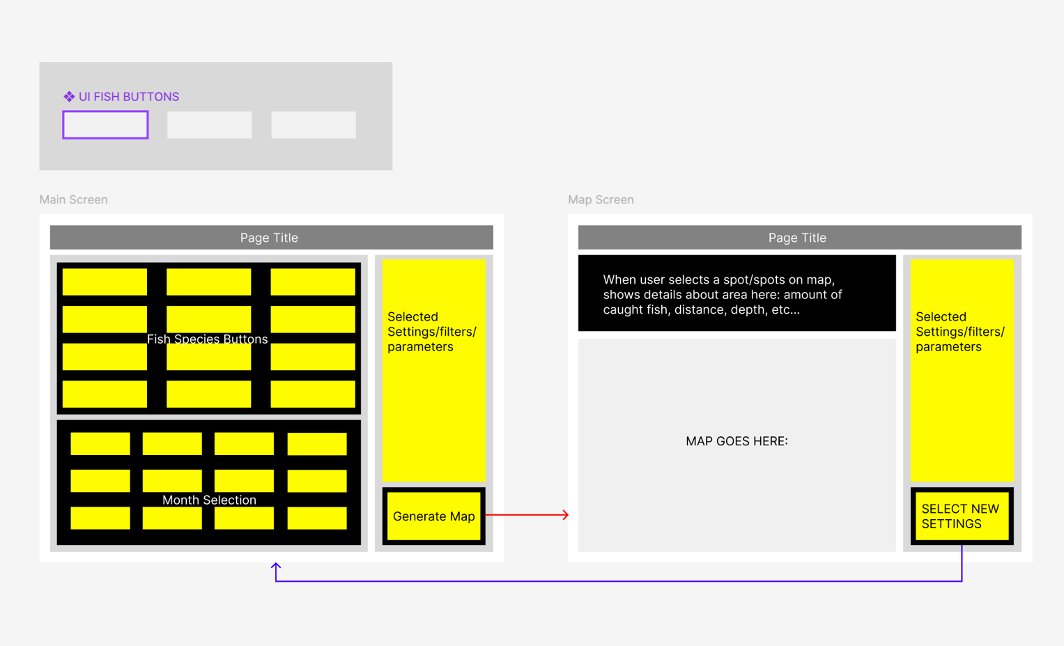

Training:
Since the enterprise system will be designed as a highly intuitive and oversized graphical user interface which has been designed specifically to provide combat against the environment in which the system is intended to be used, the amount of training required for a fishing charter operator to be able to utilise this system effectively is minimal. Training for this system could be handled via a short video explanation of the interface and the different options, or even a small pamphlet that comes in the mail with the purchase receipt (if chosen). During the start of the pilot implementation plan, it would be best for a quick in-person explanation of the system to the operators, to allow for questions to be answered, but to also gauge real-time reactions to the enterprise system. The training will mainly focus on explaining the different combinations that are available for filters as well as interpreting and interacting with the heatmaps generated from their inputs, such as coordinate copying and distance calculations.

Preferred System Implementation Method:
The recommended approach to implement this enterprise system would be the pilot implementation method. This allows the software to be released out to only a select few customers instead of sending it out straight away to an entire fleet of vessels, minimising the risk that if something in the system goes wrong, the potential damage can be minimised. The use of a pilot implementation method also allows for direct customer testing by providing a select few vessels with the proposed system to test its functionality, such as offline capabilities, environmental conditions and UI usability.

